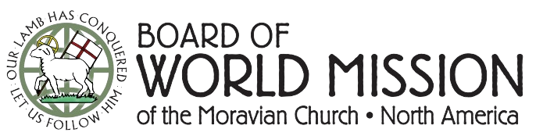

**Mission Minute:**

**BWM Mission Grants Provide New Classrooms**

In 2023, the Board of World Mission provided two mission grants to the Comenius Polytechnic Institute (CPI) in Tabora, Tanzania, to construct new classrooms. The Institute trains Moravian leaders and ministers while fostering Moravian faith in Western Tanzania.

In January 2025, the BWM Outreach Committee met with Brother Ezekiel Kassanga to hear a detailed update on this grant-funded project. Br. Kassanga expressed gratitude for the support and highlighted the growth that the college has seen in recent years. They graduated 11 pastors in 2023 and five in 2024, including three women – Br. Kassanga emphasized the college’s dedication to gender inclusion.

Classroom construction, initiated in 2022, has progressed through local funds, in addition to the two $5,000 mission grants from the BWM. These grants funded walls and roofing, while internal CPI funds supported further work such as plastering, wiring, and windows. One classroom is now functioning (as you can see in the picture below), even as they continue work like tiling and painting.

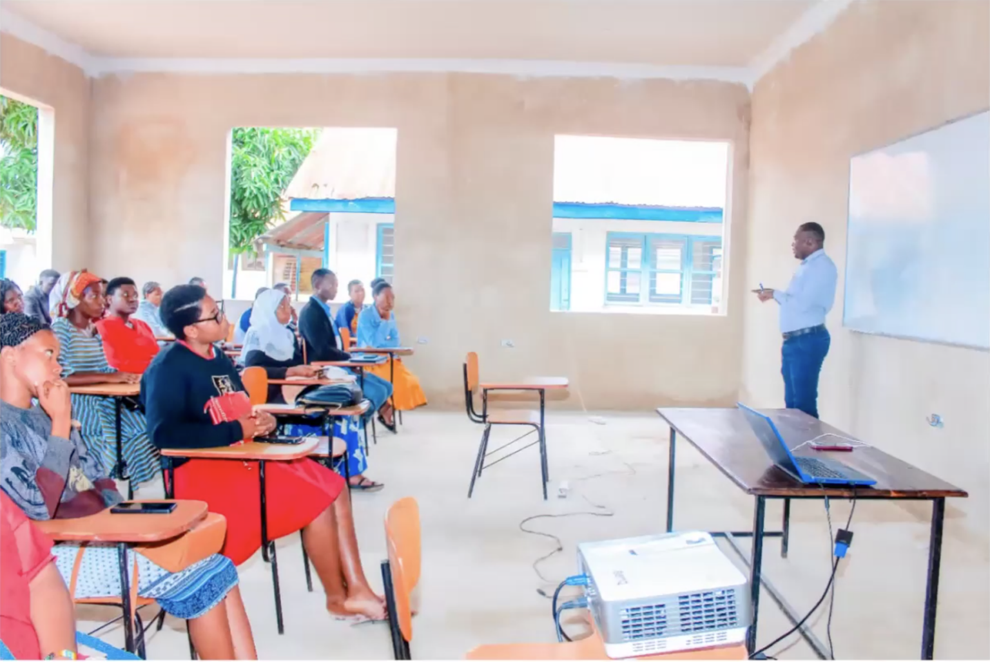

*Thank you for your support of the BWM’s Mission Grants program, which allow us to provide direct support for needs and ministries as they are identified by our global partners.*